**CHAPTER 4**

# RESULTS AND DISCUSSION

This chapter presents the findings of the study, which examined the effectiveness of the developed web application in assisting pet owners, veterinarians, and local government units (LGUs) in managing rabies vaccination records and ensuring compliance with the Anti-Rabies Act of 2007. The results provide insights into the system's usability, efficiency, and potential impact on rabies prevention efforts.

**4.1 System Development**

The system block diagram illustrates the structure of a web application created to support pet owners, veterinarians, and local government units (LGUs) in dealing with rabies vaccination records and compliance with the Anti-Rabies Act of 2007. It sohws how the web application serves as a centralized, automated platform that links all stakeholders involved, simplifies the process of rabies vaccination management, enforces compliance with the Anti-Rabies Act, and facilitates the overall objective of rabies prevention. The efficient communication among pet owners, veterinarians, and LGUs is made possible by the web application, leading to a more efficient and well-organized means of rabies prevention.

*Figure 4.1.1 System Block Diagram of Web Application*

At the heart of the system, Pet Owners, themselves are tasked with registering their pets into the web application. They provide simple pet information, including the pet's name, breed, age, and vaccination history. The system enables pet owners to monitor their pet's vaccination status, receive reminders for forthcoming vaccinations, and change their contact details. This direct interaction ensures that pet owners themselves are reminded of their obligations under the Anti-Rabies Act.

The Veterinarians are responsible for maintaining and updating vaccination records for pets. Upon giving vaccinations, veterinarians record minute details into the system, such as the type of vaccine given, date of vaccination. The web application enables veterinarians to directly communicate with pet owners, send updates or reminders, and keep track of vaccinations accurately. Such upgrades are crucial for the proper documentation and retrieval, when necessary, of every pet's vaccination history.

It is the duty of the Local Government Units (LGUs) to coordinate the implementation of the Anti-Rabies Act at the local levels. They have access to veterinarians' data on vaccinations and can monitor for compliance with law. The system gives LGUs access to real-time reports that identify vaccination rates, compliance figures, and areas of concern. LGUs can create compliance reports and, if needed, send enforcement notices to veterinarians or pet owners to act, so that no pet is left unvaccinated. This capability increases the capacity of LGUs to monitor the effectiveness of rabies prevention programs at the local level.

The Web Application System is the hub where all the data inputs are gathered and processed. The system consolidates the different stakeholders—pet owners, veterinarians, and LGUs—by keeping the vaccination records, sending reminders, and creating compliance reports. The system checks for vaccination information and sends notifications automatically to the concerned parties (reminders to pet owners, updates to veterinarians, and compliance reports to LGUs). In the process, the system facilitates the ease of vaccination schedule management and ensures that all the stakeholders involved are in accordance with their attempts to rabies.

**4.1.1 Software Description**

* Discuss features (Textual Form)

**4.2 Prototype Design**

* + 1. **Software Development**

**Web Application**

-Login Page, Home Page, Admin Page, Registration of Users and Admin, etc…

-Discuss all features, process, functions and procedures and the whole User Interface

-include images/screenshots and discuss fully

Resolution: The smallest change that can be reliably detected

Response time: The time between a triggering event and the resulting action Bandwidth: The amount of information processed per time

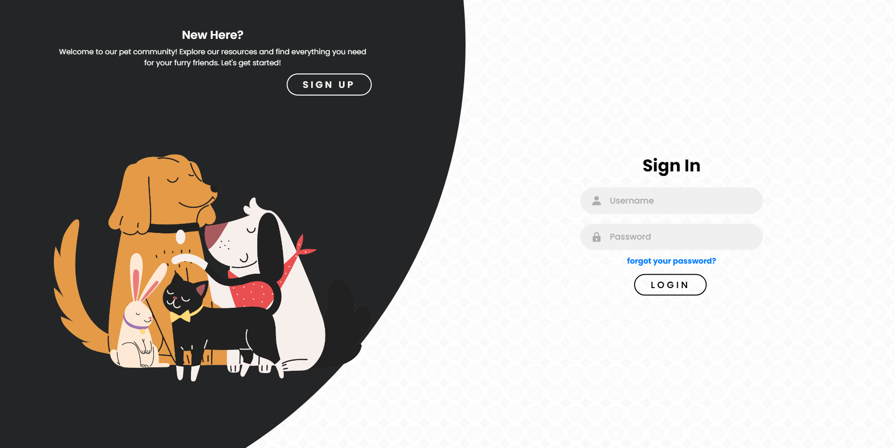

*Figure 4.2.1. Sign In Page*

Sign-In Page provides secure access to the system for users (pet owners, veterinarians, LGUs). It features fields for Username and Password with an option Forgot Your Password for recovery of the account. Upon entering the credentials, users may click Login to enter the system's functions and safely manage vaccination records. This guarantees only the authorized personnel have access to the sensitive information, thusgiving a boost to the overall web application security and integrity. The loading time takes about xx secs to process.

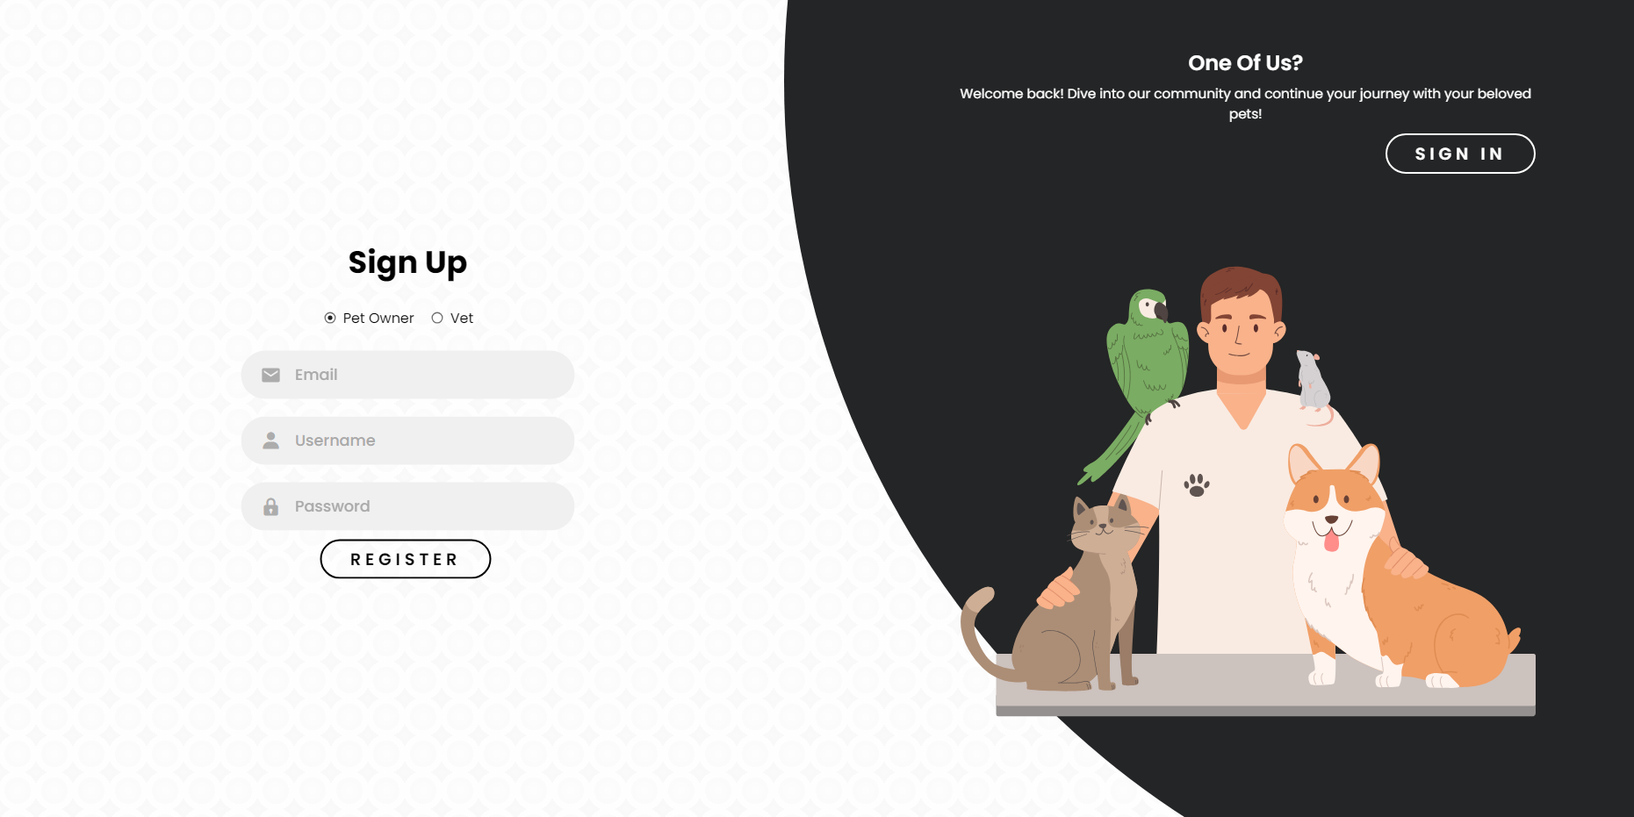

*Figure 4.2.2. Sign Up Page for Pet Owner*

The pet owner's Sign-Up Page enables new users to sign up and create an account by inputting their Email, Username, and Password. After entering the required information, users can press Register to set up their account and gain access to the system for managing vaccination records of pets. The loading time takes about xx secs to process.

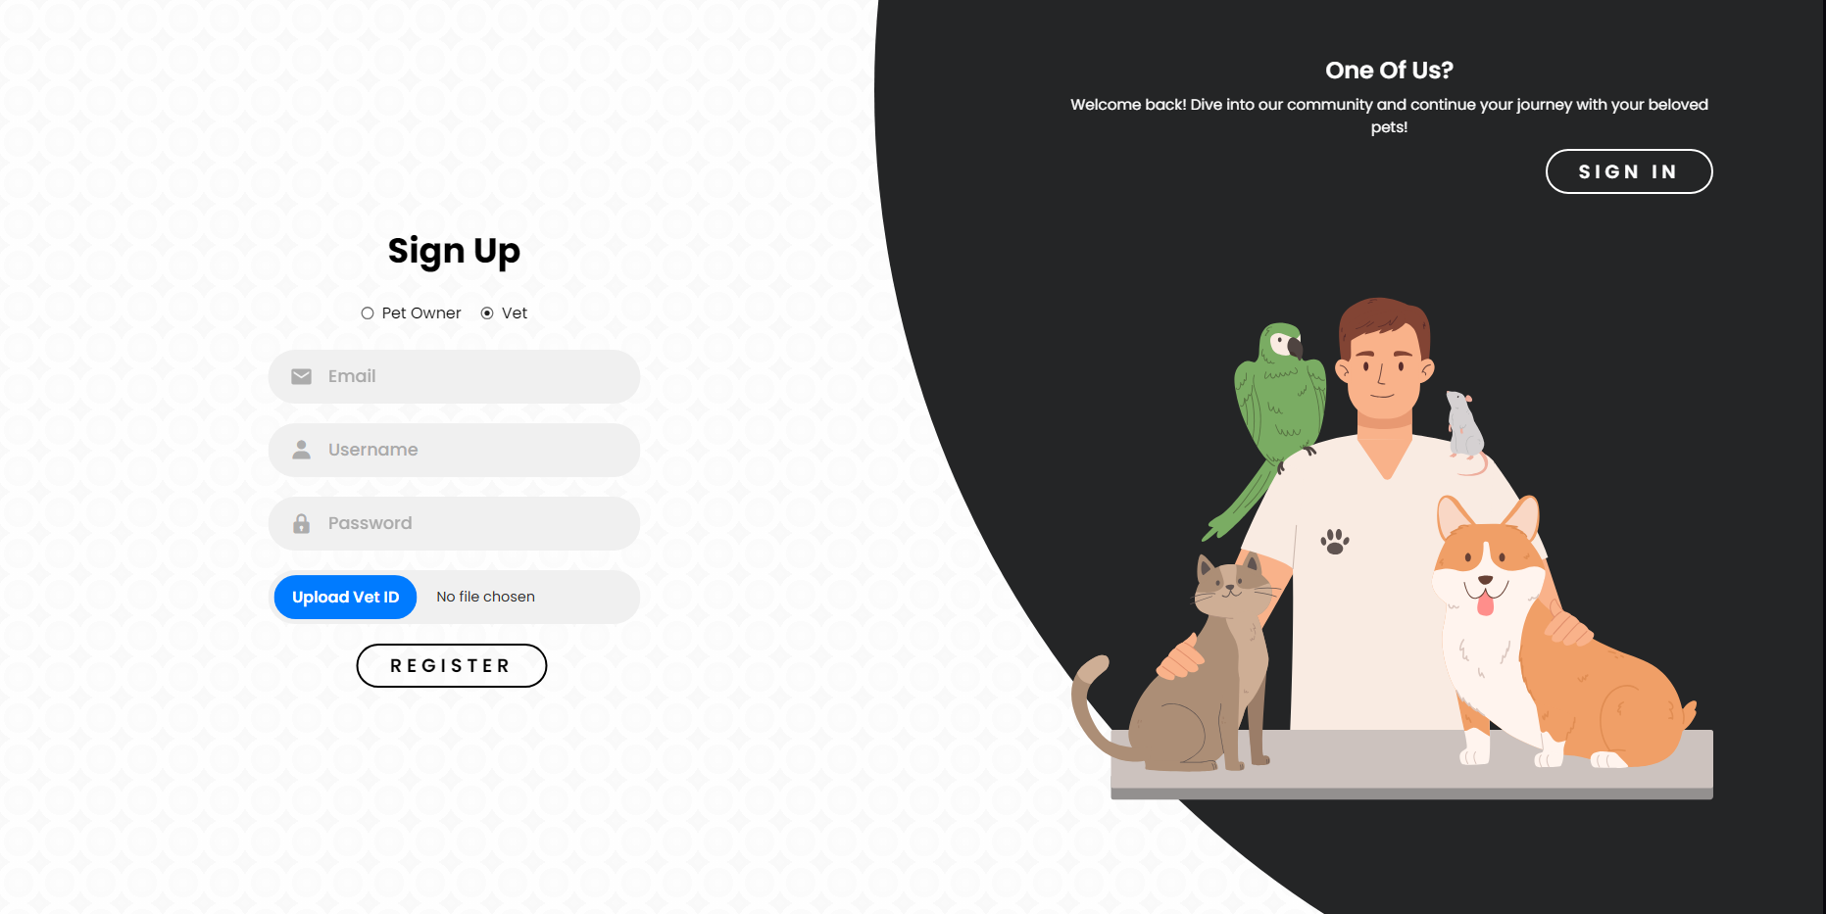

*Figure 4.2.3. Sign Up Page for Veterinarian*

Vet Sign-Up Page enables new users to register an account by entering their Email, Username, and Password. Apart from these, veterinarians must Upload their Vet ID for authentication. Upon form submission and clicking the Register button, the system checks the details and provides access to the site for pet vaccination records management and other veterinary functions. The loading time takes about xx secs to process.

**PET OWNER SECTION:**

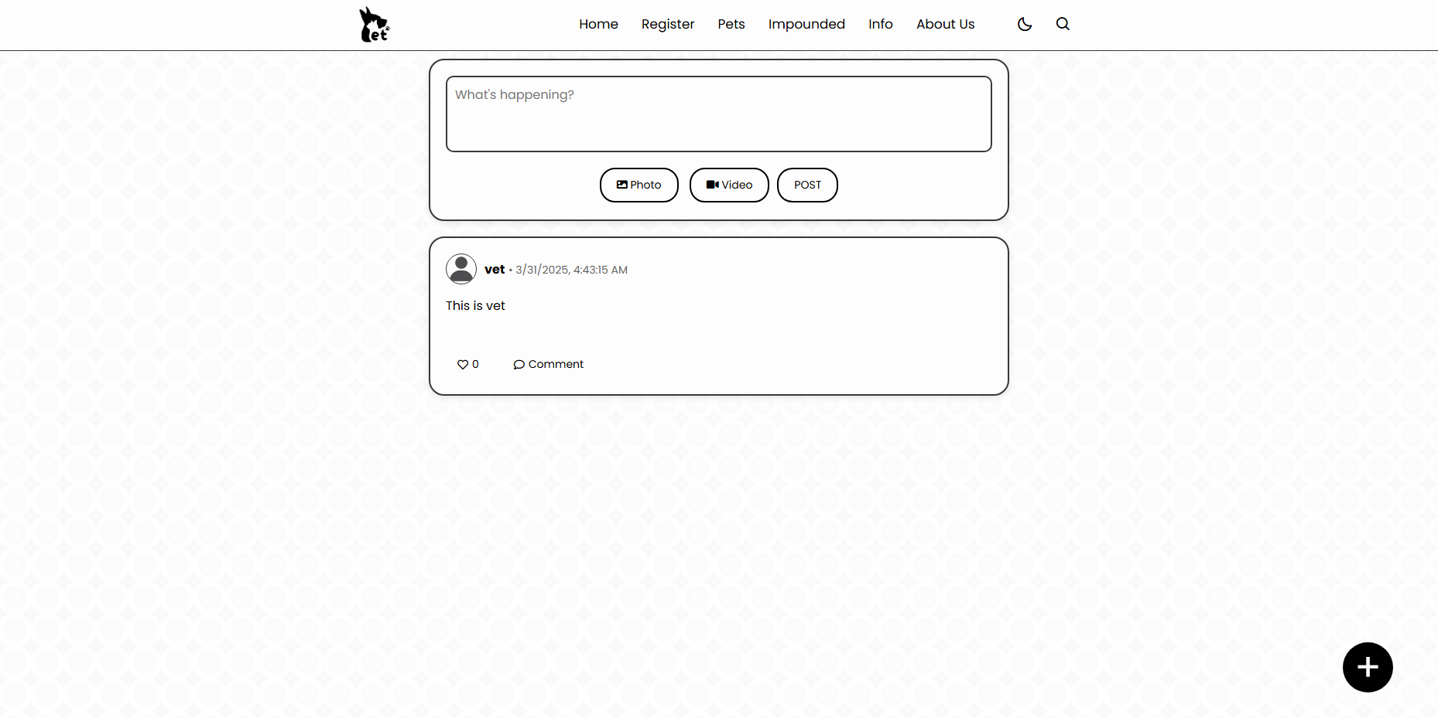

*Figure 4.2.4. Home Page for Pet Owner*

The Pet Owners Home Page is the master dashboard that provides easy access to major features. Users can easily access sections such as Register (for new pet additions), Pets (for viewing and maintaining pet records), Impounded (for lost or found pet records), and Info (for rabies vaccination status updates). The About Us area gives details regarding the platform, whereas the Night Mode feature supports a darker theme for easier reading during nighttime. The Search option facilitates locating individual pet records or updates. The page is created in the form of a news feed, and pet owners can post updates, share news, and remain updated about vaccination schedules and other related issues.

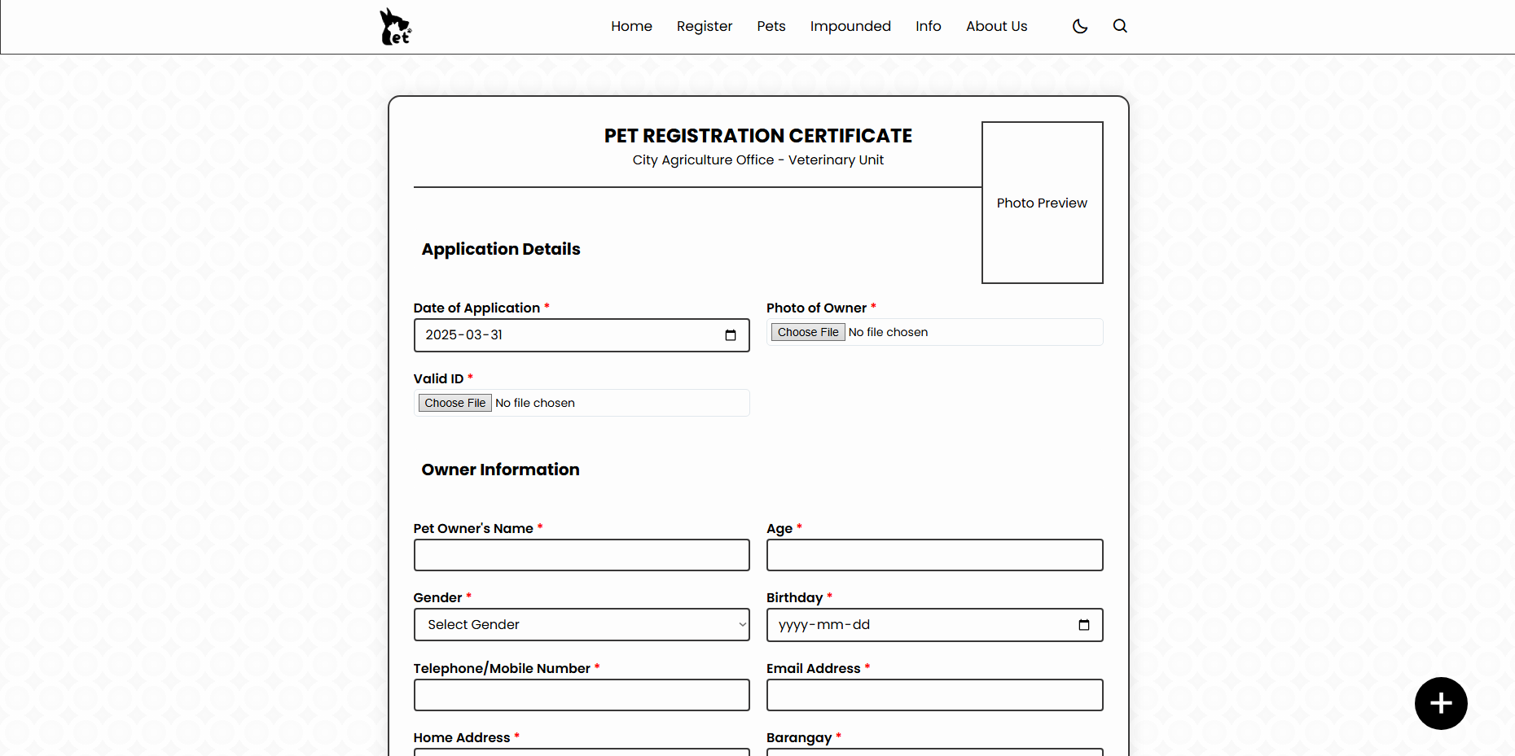

*Figure 4.2.5. Pet Registration Page for Pet Owners*

The Pet Owners Registration Page allows users to register their pets by providing information that is applicable. Pet owners can upload the pet photo, owner photo, and identification proof for verification purposes. The form will also accept the owner's information such as name, age, gender, birthday, email, contact number, and address. Basic information on the pet and vaccination status, is needed, along with the contact details of the veterinarian who administered the vaccination. Finally, the owner needs to sign and date the form to complete the registration. The time it takes to submit the application takes xx secs.

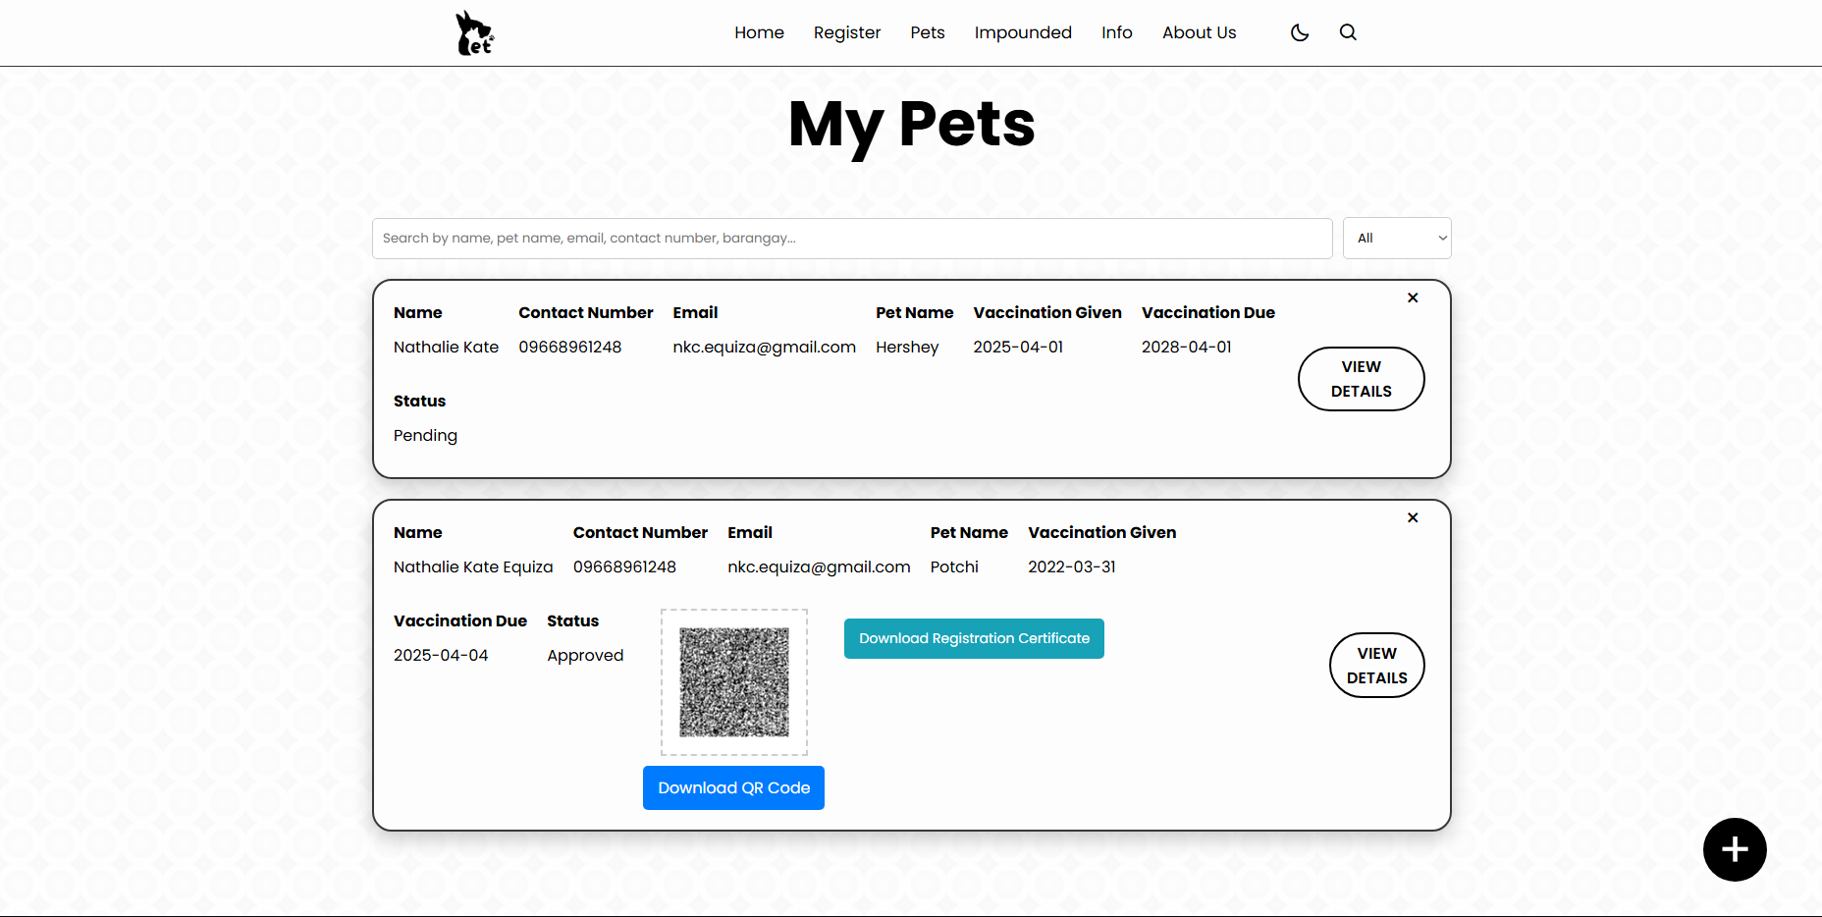

*Figure 4.2.6. Registered Pets Page for Pet Owners*

The Registered Pet Page for owners of pets shows important information regarding the pet and the owner. It shows the owner's name, contact number, email, as well as the pet's name, vaccination administered, vaccination due, and status (up to date, overdue). A QR code is also created that holds all the important pet details, allowing pet owners to easily access or share important details in case the pet is lost. The time it takes to generate the QR code takes xx secs.

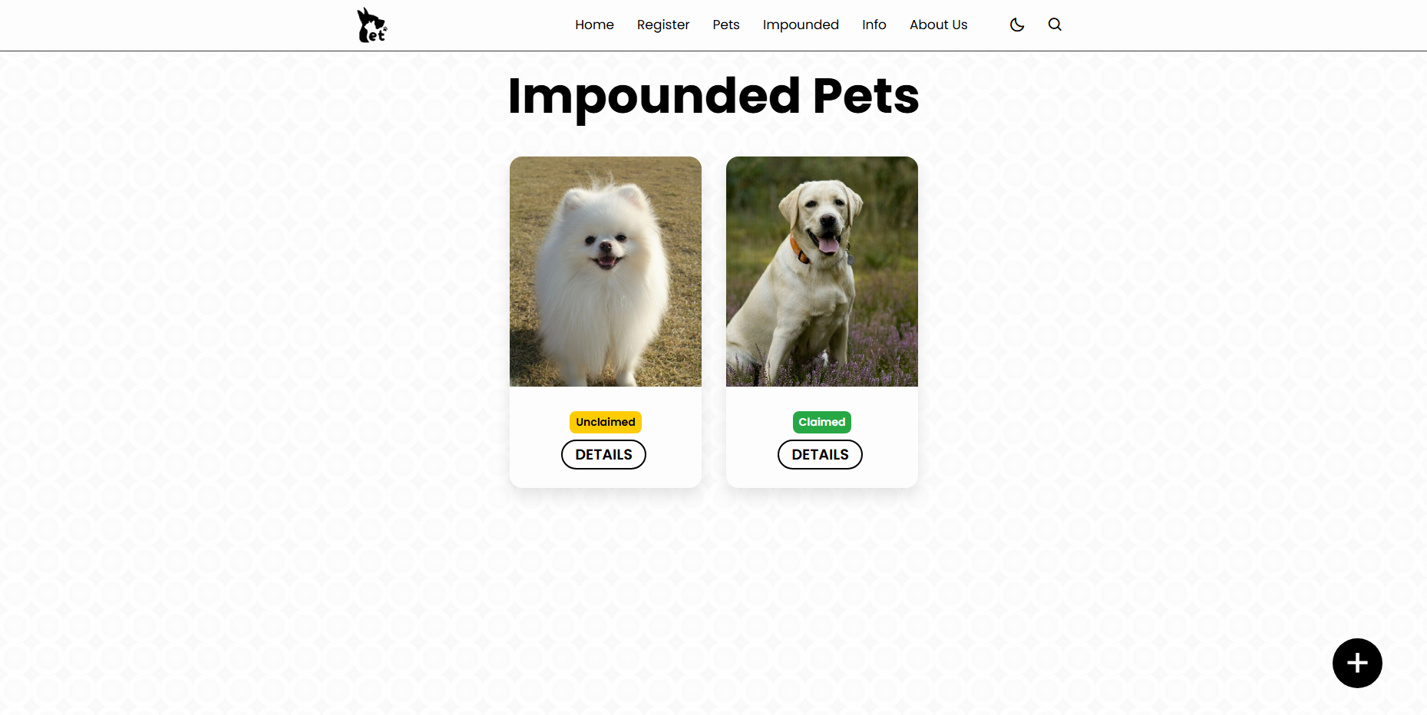

*Figure 4.2.7. Impounded Pets Page for Pet Owners*

The Impounded Page for pet owners gives details of pets that were found or impounded. It consists of two categories: Unclaimed Pets, which shows animals still waiting for their owners, and Claimed Pets, showing animals that have already been reunited with their owners. The page assists pet owners in monitoring missing pets in their neighborhood and taking action to retrieve their animals if need be. The time it takes to load takes xx secs.

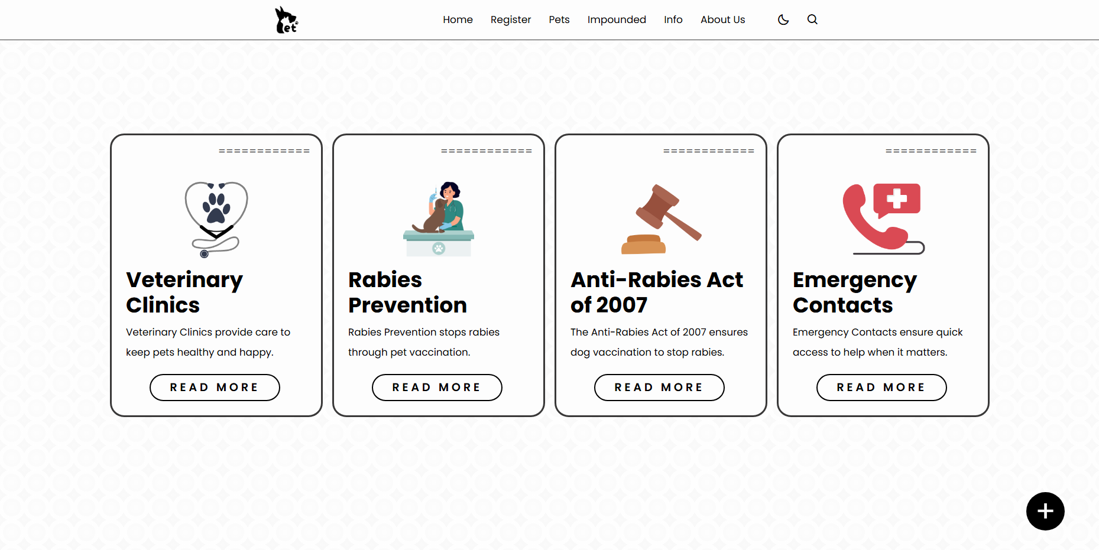

*Figure 4.2.8. Information Page for Pet Owners*

The Info Page is important in that it offers key information for pet owners. The page contains a listing of Vet Clinics to conveniently access veterinary facilities in the local area, Rabies Prevention guidelines, and details of the Anti-Rabies Act to educate the owners about responsible pet practice. The page further offers a listing of Emergency Contacts so that the owners have speedy access to contact numbers during emergent circumstances. The time it takes to load each tab takes xx secs.

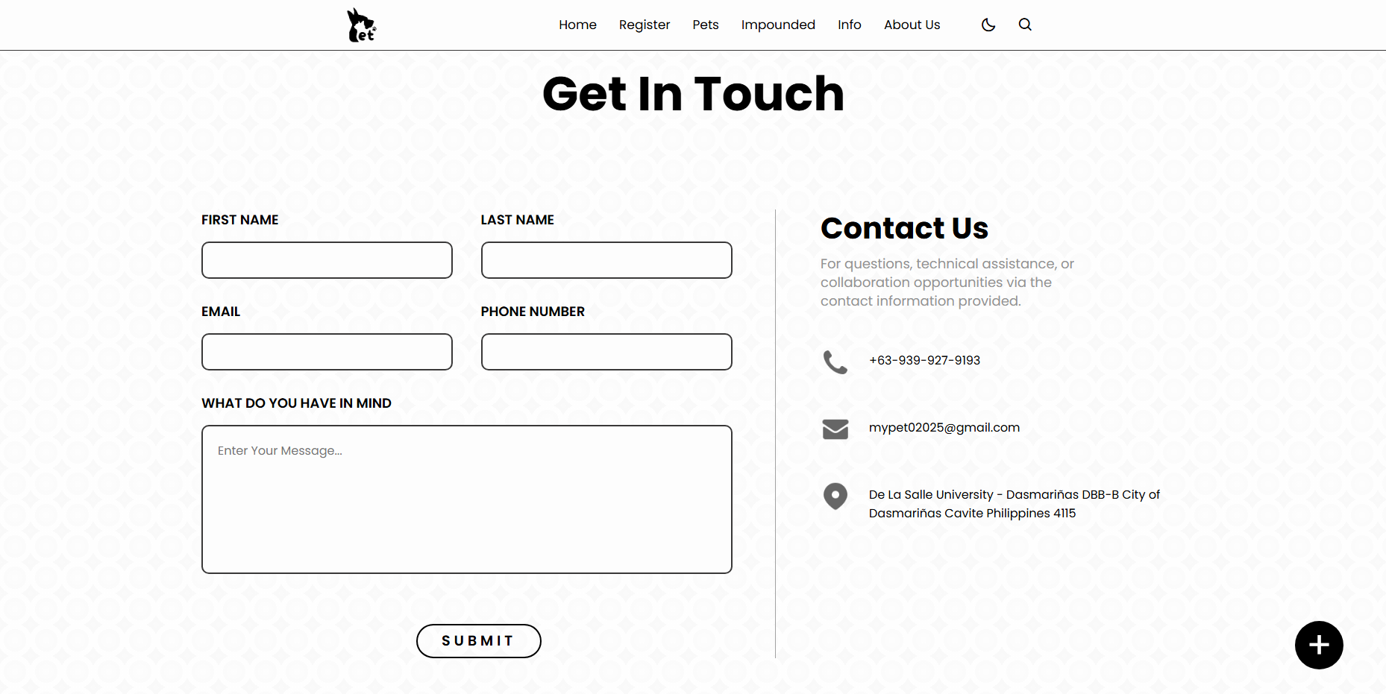

*Figure 4.2.9. About Us Page for Pet Owners*

The About Us Page for pet owners creates a platform where one can learn more about the site and what they do. One is free to fill in their basic information such as first name, last name, phone number, email, and comment or give feedback regarding the service. It also has contact information for the web developer, so users can contact them in case of support or questions. The loading time takes about xx secs to process.

**VETERINARIAN SECTION**

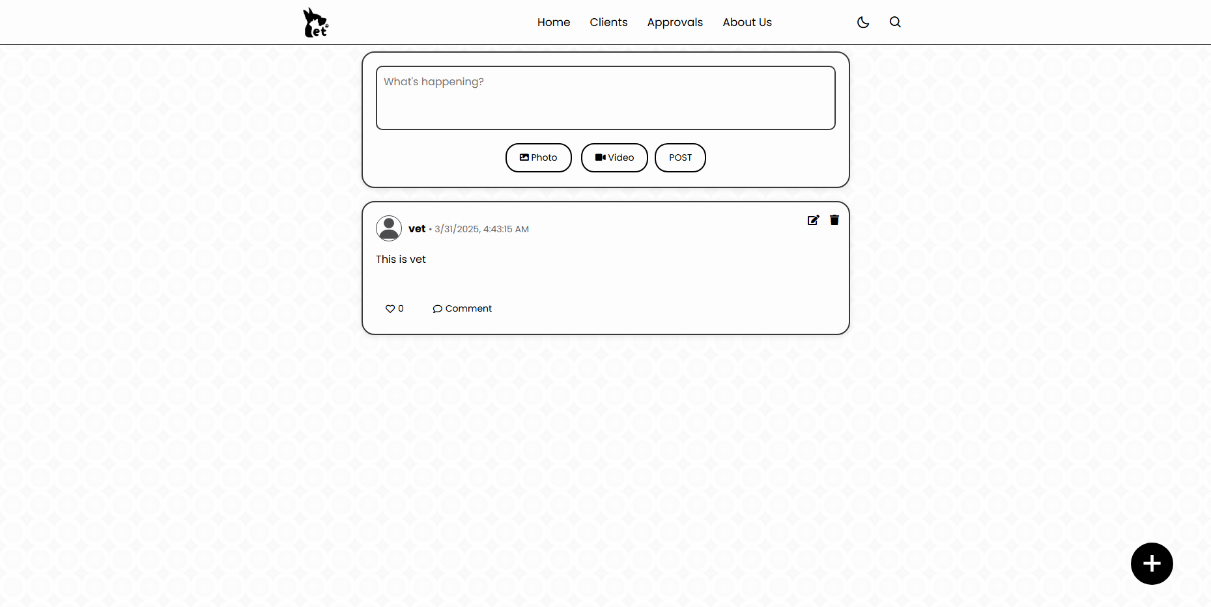

*Figure 4.2.10. Home Page for Veterinarian*

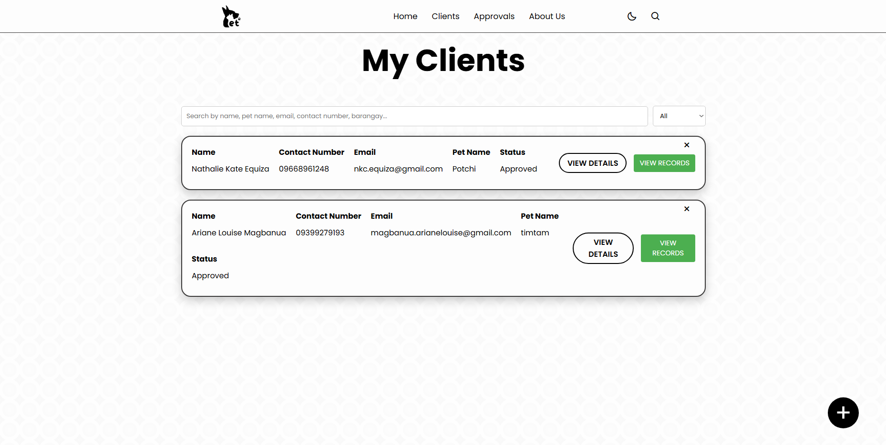

*Figure 4.2.11. Clients Page for Veterinarian*

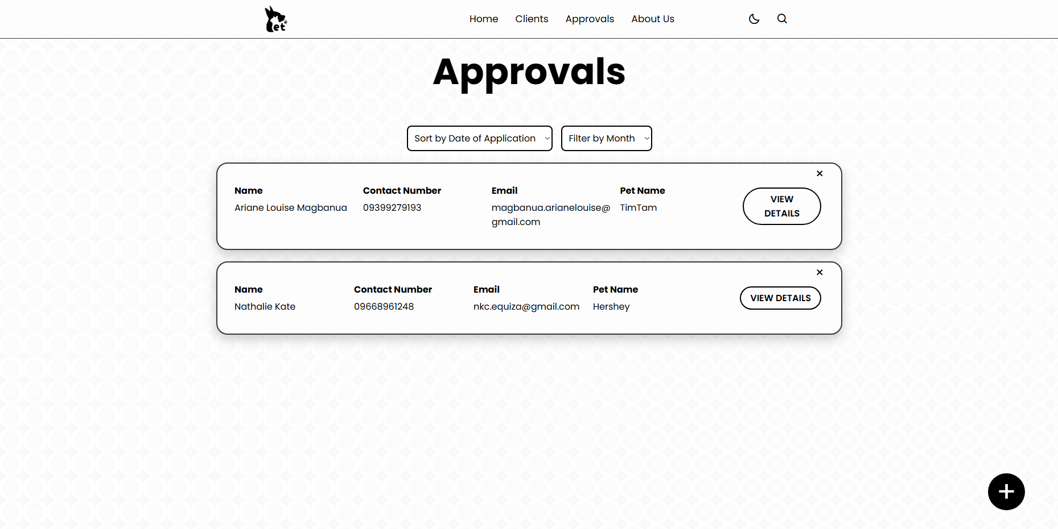

*Figure 4.2.12. Approvals Page for Veterinarian*

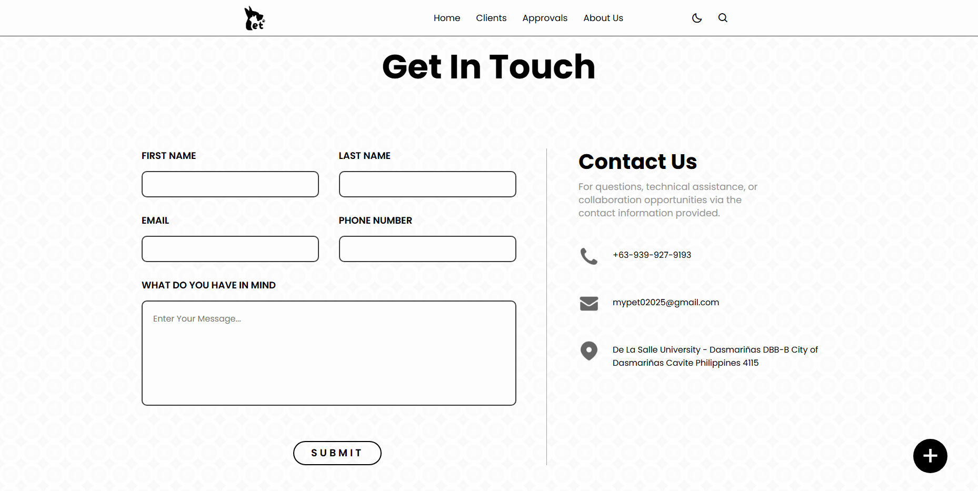

*Figure 4.2.13. About Us Page for Veterinarians*

**LGU SECTION**

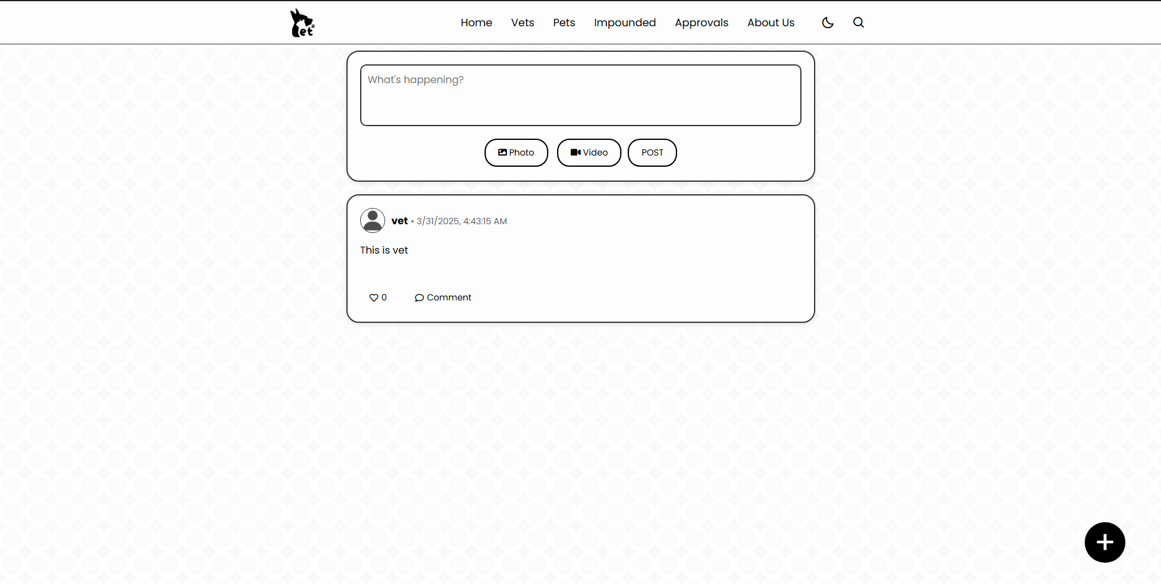

*Figure 4.2.14. Home Page for LGU*

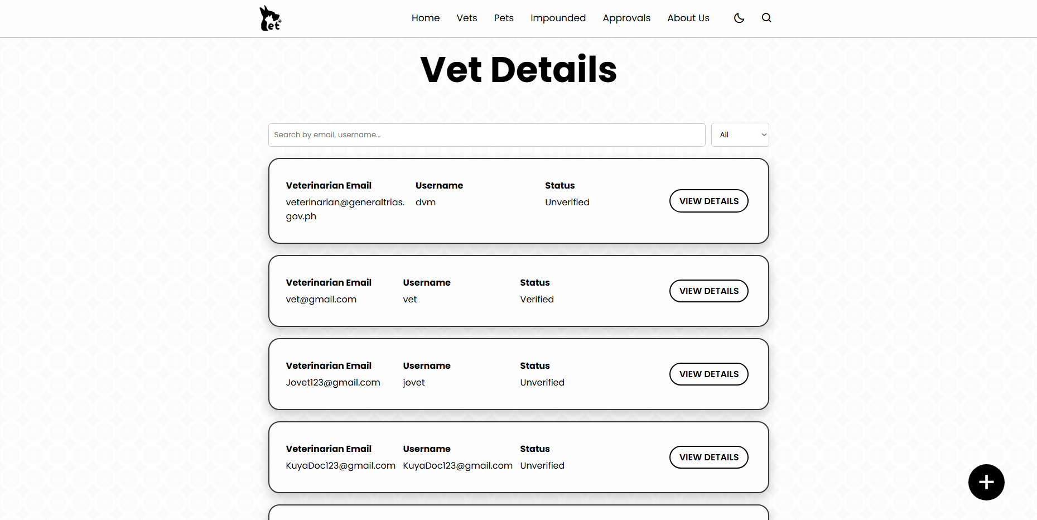

*Figure 4.2.15. Veterinarian Details Page for LGU*

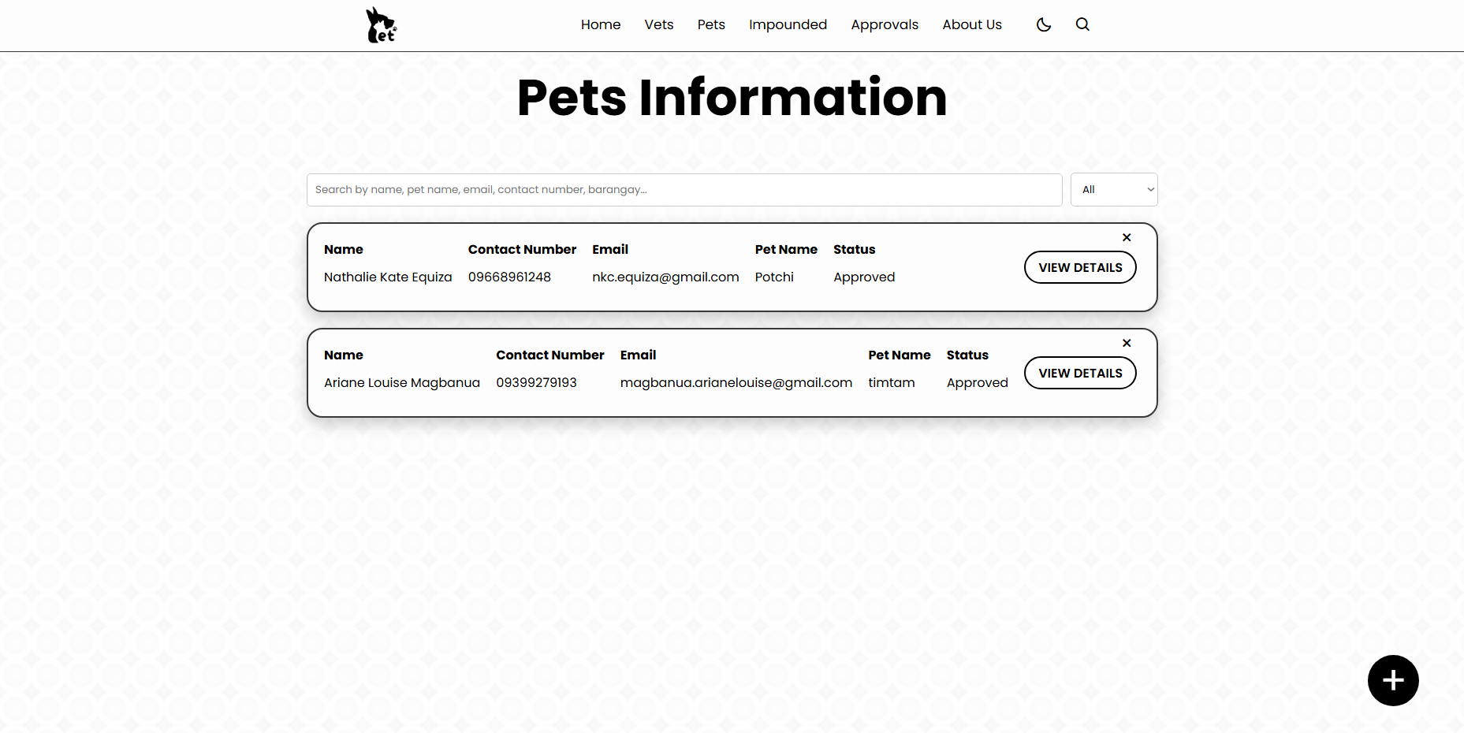

*Figure 4.2.16. Pets Information Page for LGU*

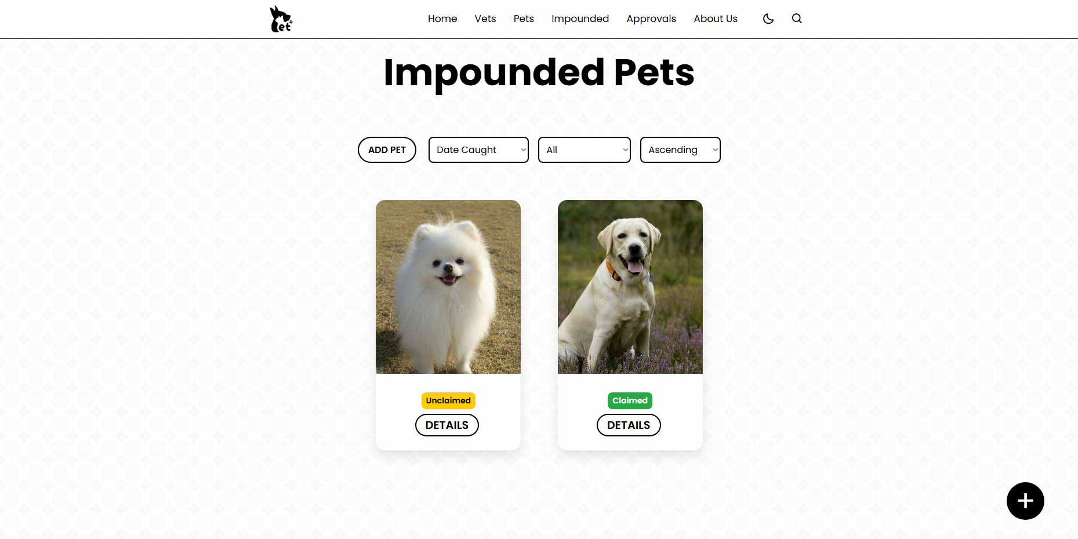

*Figure 4.2.17. Impounded Pets Page for LGU*

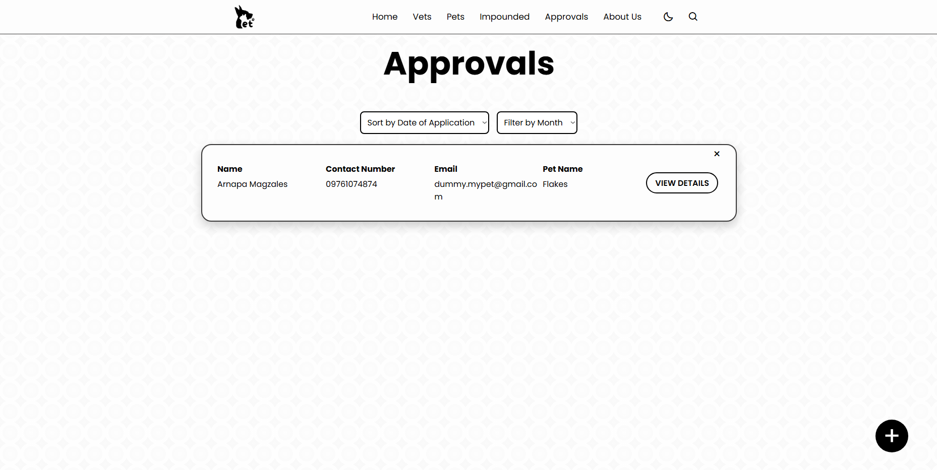

*Figure 4.2.18. Approvals Page for LGU*

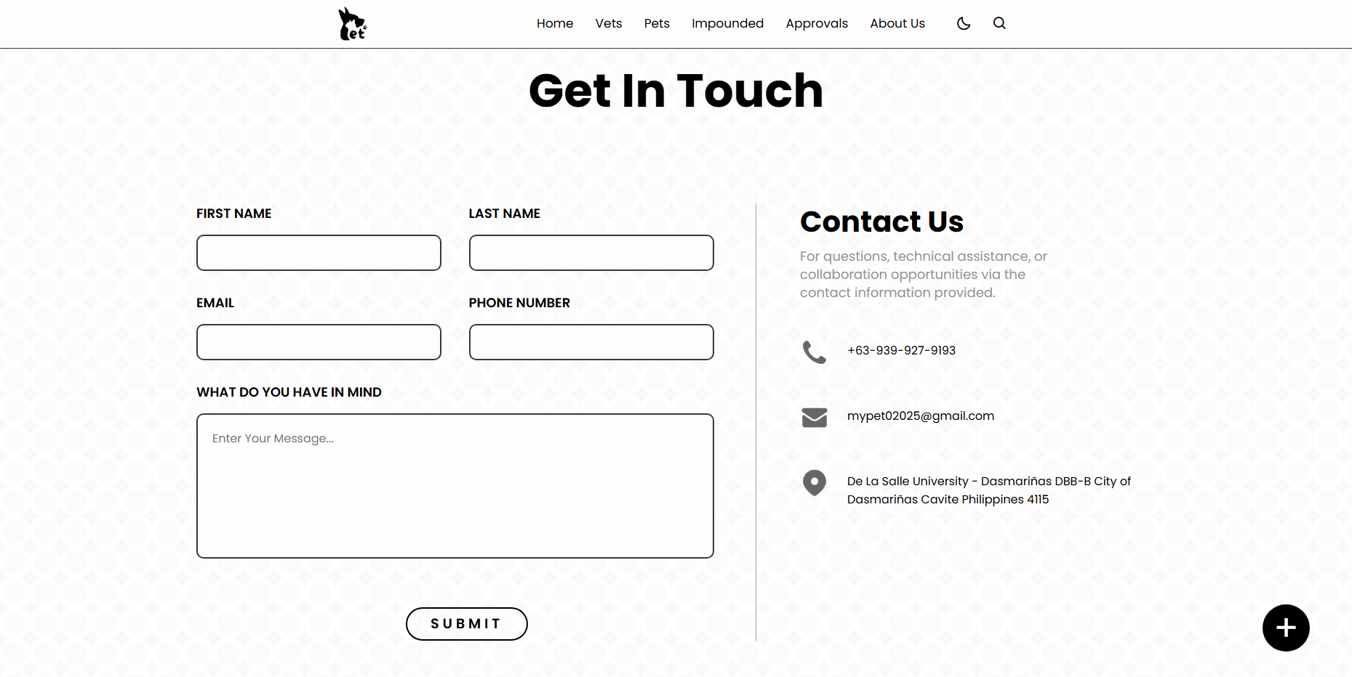

*Figure 4.2.19. About Us Page for LGU*

**4.2.2 Database Design**

The database for the "Development of a Web-Application for the Local Government Unit for Implementing the Anti-Rabies Act" is designed to store and manage data related to pet registration, impounded pets, user interactions, and community engagement. Below is a brief discussion of its key tables:

|  |  |  |
| --- | --- | --- |
| **Column Name** | **Data Type** | **Description** |
| UserID | int(11) (PK) | Unique user ID |
| Name | varchar(60) | Full name of the User |
| Bio | text | Short bio of the user |
| Username | varchar (255) | Unique username |
| Gender | varchar (60) | Gender of the user |
| Email | varchar(255) | User email (unique) |
| Password | varchar(255) | Hashed password |
| ProfilePic | varchar(255) | File path for profile picture |
| BirthDate | date | Birthdate of the user |
| Contact | varchar(60) | Contact number |
| Link_Address | longtext | Address details |
| Role | varchar(255) | Role (e.g., pet owner, admin) |
| license_proof | varchar(255) | Path or URL to the license of the users |
| otp_code | varchar(10) | One-time password code for verification |
| otp_expiry | datetime | Expiry date and time of the OTP |
| status | int(11) | 0 = unverified, 1 = verified, 2 = deleted |

*figure 4.-.- User Database Table*

**Users Database Table:** The users table stores essential information about individuals who access the system, including pet owners, veterinarians, and government officials. This table contains details such as the user's full name, email address, contact number, and assigned role (e.g., administrator, pet owner, or veterinarian). By maintaining these records, the system ensures secure authentication and role-based access control.

|  |  |  |
| --- | --- | --- |
| **Column Name** | **Data Type** | **Description** |
| pet_id | int (11) (PK) | Unique pet ID |
| pets_UserID | int(11) | ID of the owner |
| pet_photo_owner | varchar(255) | Owner’s photo |
| pet_validIDName | varchar(255) | Owner’s valid ID image file |
| pet_date_application | date | Date of pet registration |
| pet_owner_name | varchar(60) | Name of the pet owner |
| pet_owner_age | int(11) | Age of the owner |
| pet_owner_gender | varchar(60) | Gender of the owner |
| pet_owner_birthday | date | Birthdate of the owner |
| pet_owner_telMobile | varchar(60) | Owner’s contact number |
| pet_owner_email | varchar(60) | Owner’s email address |
| pet_owner_home_address | varchar(60) | Owners home address |
| pet_owner_barangay | varchar(255) | Barangay of the owner |
| pet_name | varchar(60) | Name of the pet |
| pet_age | varchar(60) | Age of the pet |
| pet_gender | varchar(60) | Gender of the pet |
| pet_species | varchar(60) | Species of the pet (e.g., Dog) |
| pet_breed | varchar(60) | Breed o the pet |
| pet_weight | varchar(60) | Weight of the pet |
| pet_color | varchar(60) | Color of the pet |
| pet_marks | varchar(60) | Distinguishing marks of the pet |
| pet_birthdate | date | Pet’s date of birth |
| pet_antiRabies_vac_date | date | Date of last anti-rabies vaccination |
| pet_antiRabies_expi_date | date | Expiration date of the anti-rabies vaccination |
| pet_antiRabPic | varchar(255) | File path of the vaccination proof |
| pet_vet_clinic | varchar(255) | Name of the vet clinic |
| pet_vet_name | varchar(60) | Name of the Veterinarian |
| pet_vet_clinic_address | varchar(255) | Address of the vet clinic |
| pet_vet_contact_info | varchar(255) | File path of the owner’s signature |
| pet_date_signed | date | Date when the owner signed the registation |
| pet_qr_code | varchar(255) | QR code for pet identification |
| pet_status | varchart(255) | Status of the pet’s registration (e.g., pending, declined_by_vet) |

*fig 4.-.- Pets Info Database Table*

**Pets Info Database Table:** This table maintains records of registered pets, linking them to their respective owners. It stores pet details such as species, breed, age, and vaccination status. The inclusion of a foreign key that references the users table ensures that each pet is associated with a registered owner. This table plays a crucial role in tracking pet vaccination compliance and facilitating responsible pet ownership.

|  |  |  |
| --- | --- | --- |
| **Column Name** | **Data Type** | **Description** |
| imp_id | int(11) (PK) | Unique ID for the impounded pet |
| imp_date_caught | date | Date when the pet was caught |
| imp_location_found | varchar(255) | Location where the pet was found |
| imp_location_impound | varchar(255) | Location where the pet was impounded |
| imp_days_rem | int(11) | Number of days remaining before the action is taken |
| impo_impounded_photo | varchar(255) | File path of the impounded pet’s photo |
| impo_notes | text | Additional notes about the pet |
| imp_status | varchar(50) | Current status of the impounded pet (e.g., Unclaimed, Pending) |
| imp_claim_by | int(11) | ID of the user claiming the pet (nullable) |

*fig 4.-.- Impounded Pets Database Table*

**Impounded Pets Database Table:** The impounded_pets table documents animals that have been captured and placed under local government custody. It includes details such as the date of capture, the location where the pet was found, and the deadline for claiming the pet before further actions are taken. The table is linked to the pets_info table, enabling authorities to verify ownership and determine the next course of action, such as reunification with the owner.

|  |  |  |
| --- | --- | --- |
| **Column Name** | **Data Type** | **Description** |
| post_id | int(11) (PK) | Unique identifier for each post |
| post_date | timestamp | Date and time of post creation, updated on modification |
| post_user_id | int(11) | ID of the user who created the post (Foreign Key to users.UserID) |
| post_content | text | Content of the post (text-based). |
| post_images | longtext | Stores image URLs or paths (supports multiple images) |
| post_status | int(11) | Status of the post (0=deleted, 1=existing) |

*fig 4.-.- Community Posts Database Table*

**Community Posts Database Table:** The system includes a feature that allows users to create and share posts related to lost pets, and public awareness campaigns. The posts table stores information about user-generated content, including the title, description, category, and timestamp of the post. This feature enhances public participation and serves as a platform for spreading information relevant to pet welfare and disease control.

|  |  |  |
| --- | --- | --- |
| **Column Name** | **Data Type** | **Description** |
| comments_id | int(11) (PK) | Unique identifier for each comment |
| comments_post_id | int(11) | ID of the post being commented on (Foreign Key to post_content.post_id) |
| comments_user_id | int(11) | ID of the user who made the comment (Foreign Key to users.UserID) |
| comments_text | text | The actual comment text |
| comments_date | timestamp | Timestamp of the comment, updated on modification |

*fig 4.-.-*

**Post Comments Database Table:** To foster interaction within the community, users can comment on posts. The post_comments table stores comments made on specific posts, capturing details such as the comment text, user ID, and timestamp. This feature allows for discussions on lost pet reports, and other pet-related concerns.

|  |  |  |
| --- | --- | --- |
| **Column Name** | **Data Type** | **Description** |
| like_id | int(11) (PK) | Unique identifier for each like |
| like_user_id | int(11) | ID of the user who liked the post (Foreign Key to users.UserID) |
| like_post_id | int(11) | ID of the post that was liked (Foreign Key to post_content.post_id) |
| like_action | varchar(60) | Type of like action (e.g., “heart”) |

*fig 4.-.-*

**Post Likes Database Table:** In addition to comments, users can express support for posts through a "like" feature. The post_likes table records instances of users liking posts, thereby increasing engagement and visibility of important community announcements.

|  |  |  |
| --- | --- | --- |
| **Column Name** | **Data Type** | **Description** |
| chat_id | int(11) (PK) | Unique identifier for each chat message |
| sender_id | int(11) | ID of the user sending the message (Foreign Key to users.UserID) |
| receiver_id | int(11) | ID of the user receiving the message (Foreign Key to users.UserID) |
| message_text | text | Content of the message |
| message_media | varchar(255) | Path or URL to any attached media (optional) |
| message_status | int(11) | Status of the message (0=deleted, 1=existing) |
| message_seen | int(11) | Seen status (1=seen, 0=unseen) |

*fig 4.-.- Chat Messages Database Table*

**Chat Messages Database Table:** To facilitate direct communication between users, the system includes a messaging feature. The chat_messages table stores messages exchanged between users, ensuring private and secure communication regarding lost pet reports, and other concerns.

|  |  |  |
| --- | --- | --- |
| **Column Name** | **Data Type** | **Description** |
| ph_id | int(11) (PK) | Unique identifier for each pet history update |
| ph_pet_id | int(11) | ID of the pet (Foreign Key to pets_info.pet_id) |
| ph_pet_antiRabies_vac_date | date | Date when the pet received the anti-rabies vaccination |
| ph_pet_antiRabies_expi_date | date | Expiry date of the anti-rabies vaccination |
| ph_update_at | timestamp | Timestamp of the update, automatically updated on modification |

*fig 4.-.- Pets Info History Update:*

**Pets Info History Update:** The pets_info_history_update table keeps track of updates to a pet’s anti-rabies vaccination records. This table stores the historical vaccination data of pets, ensuring that previous vaccination dates and expiry dates are preserved whenever updates occur. It helps in maintaining a timeline of a pet’s vaccination history, which is crucial for monitoring compliance with anti-rabies laws and regulations.

**4.3 Validation**

For your Guide Only

# Data Gathering Design Validation

|  |  |  |  |
| --- | --- | --- | --- |
| - Available Tools | -Design |  | -Functionality Test |
| -Experts (what the system/ | -Code |  | -Performance Test |
| Product is for) | -Build |  | -Usability Test |
| -End-users (what they want/ | Product, |  | -Experts |
| Expect from the system/product) | Software, |  | -End-users |
| -Interview | Device/Prototype |  |  |

-Survey

-Observation -Questionnaire

-etc.

4.3.1 System Testing

4.3.2 Functionality Test

4.3.3 Performance Test

4.3.4 Usability Test

4.3.5 Compatibility Test

4.3.6 Speed Test

4.3.7 Feedback from End-users (validators, benefactors)

4.3.8 Comparative Analysis Between manual and Automated

4.3.8 Cost Analysis

.

.

.

And so on, if only applicable

Note:

Data should be presented in Tabular Form, Graphical Form and Discuss fully with interpretation

Include Table Heading/Title, units and Interpretation

Include Data visualization Appendix:

Include Photodocs of Testing

Certification by the clients (Experts and End-users)

Discussion of the whole Testing process (number of participants, locations, comments and suggestions/feedback, photos)

-report accurately

-even the results are negative, report it and say the information nicely and we are after in your recommendations based on their negative feedback.

Safety: The risk to humans or the environment

Accuracy: The difference between the expected truth and the actual parameter

Precision: The number of distinguishable measurements

Maintainability: The flexibility with which the device can be modified

Testability: The ease with which proper operation of the device can be verified

Compatibility: The conformance of the device to existing standards, if can be used in different platforms

Mean time between failure: The reliability of the device, the life of a product Nonrecurring engineering cost (NRE cost): The one-time cost to design and test

Unit cost: The cost required to manufacture one additional product

Time-to-market: The time required to deliver the product to the customer

Human factors: The degree to which our customers like/appreciate the product

## System Quality Metrics

|  |  |
| --- | --- |
| **Quality** | **Operational Definition** |
| Functionality | The ability of the system to perform its specific functions. |
| Reliability and performance | The ability of the system to provide a consistent correct output and maintain fast response for the user. |
| Ease of Use | The ability of the system to provide a userfriendly layout east navigation and operation. |
| Significance | The ability of the System to solve the statement of the problem of the study. |
| Sustainability | Further improvements in terms of the system’s functionality. |